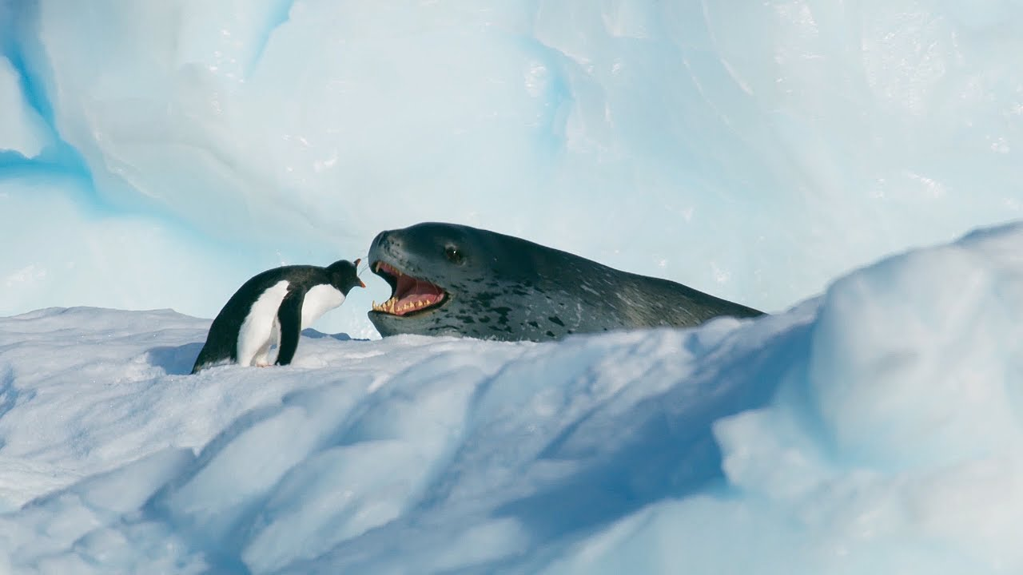

**Leopard Seal vs Penguin Clip**

<https://www.youtube.com/watch?v=XaZhOtxsUnY>

1. Sir David Attenborough opens by saying that “for some it is time to retreat.” What do you think the word ‘retreat’ means?
2. Pause at 21 seconds – Do you think the penguin has any chance of escape? Explain your answer.
3. Pause at 39 seconds – How do you think the penguin feels having leapt to safety on the rocks?
4. Sir David Attenborough says “it’s back to square one.” What do you think this phrase means?
5. What do you think it means to “run the gauntlet”?
6. Why might the penguin have no alternative but to get back into the water? Explain your answer fully.
7. Pause at 1.14 – Why do you think the director has chosen to make the penguin look so small and isolated here? Explain fully.
8. Pause at 1.32 – Why do you think the leopard seal doesn’t just grab the penguin at this point?
9. Sir David Attenborough says the seal “Seems to be toying with the penguin.” What does this mean?
10. Pause at 2.26 – Imagine you could speak penguin. What do you think the penguin just said?
11. How did you feel when the leopard seal chose to get back into the water without eating the penguin? Explain.
12. Why do you think the leopard seal made this choice?
13. Summarise this trailer in a tweet. Include an appropriate hashtag.